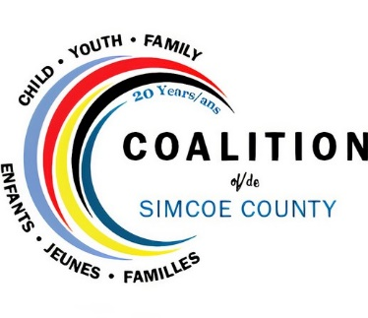
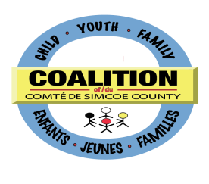
Child, Youth and Family Services Coalition
of Simcoe County

Recognition Program - Award of Excellence Nomination

The Child, Youth and Family Services Coalition of Simcoe County Recognition Program celebrates the work of the Coalition and its members by highlighting successful projects and outstanding collaboration.

To nominate an individual or project/initiative for the Coalition Award of Excellence, please review the rules and regulations and complete the brief Nomination Form below. The Coalition Coordinator will contact you to arrange a mutually convenient time to complete the balance of the Nomination Form.

Purpose
The Award of Excellence is awarded annually to either:
- an individual involved with the Coalition who, through a substantial commitment to collaboration, has made a significant impact regionally that has contributed to the outcomes identified in the Coalition’s strategic plan. This impact extends beyond one project or year.
or
- a project or initiative that demonstrates significant alignment with the Coalition’s goals and priorities, and involves collaboration between at least two member organizations.

Nominator Contact Information
Name of Organization: Click here to enter text.
First Name: Click here to enter text. | Last Name: Click here to enter text.
Title: Click here to enter text.
Daytime phone: Click here to enter text. | Alternate phone: Click here to enter text.
Email address: Click here to enter text.

Nominee Contact Information
Is the nomination for a person or an initiative?
Select
Name of Initiative/Project: Click here to enter text.
First Name: Click here to enter text. | Last Name: Click here to enter text.
Title: Click here to enter text.
Daytime phone: Click here to enter text. | Alternate phone: Click here to enter text.
Email address: Click here to enter text.
CELEBRATING 20 YEARS OF COLLABORATION

Provide 3 reasons why this individual or project/initiative is deserving of the Coalition Award of Excellence:
Click here to enter text.
Submission Deadline: October 15, 2021

Rules and Regulations
1) By participating, each person submitting a nomination, nominee, and selected winner agree:
(a) to be bound by these Rules and Regulations and the decisions of the Child, Youth and Family Services Coalition of Simcoe County Recognition Program Selection Committee
(b) to permit the Child, Youth and Family Services Coalition of Simcoe County to use his/her name, organization name, project name, photograph, video, or any likeness for advertising or publicity purposes without any additional compensation

2) The decisions of Child, Youth and Family Services Coalition of Simcoe County Recognition Program Selection Committee in relation to this recognition program will be final and binding on all entrants.

3) Should any conflict of interest arise between the members of the Selection Committee and a particular award, they will abstain from entering into discussion and remove themselves from the process for the award in question.

4) The Child, Youth and Family Services Coalition of Simcoe County shall not be responsible for incorrect or inaccurate transcription or registration of Contest entry information, technical malfunctions, lost/delayed data transmission, omission, interruption, deletion defect, faulty, incomplete, incomprehensible, or erased computer or network transmissions, line failures of any telephone network, failure of computer equipment, software, inability to access any online service or web site, inability to submit the online nomination form, or any other error or malfunction, or any injury or damage to entrant’s or any other person’s computer related to or resulting from participation or downloading any materials in the Contest, or for late, lost stolen, postage due, illegible or misdirected entries.

5) Upon receipt of the Nomination Form, the Coalition Coordinator will contact the nominator for additional information to support the nomination.

Coalition Strategic Direction
The Strategic Plan for the Child, Youth and Family Services Coalition of Simcoe County is founded on a vision where all children, youth and families thrive in a strong, nurturing community. The Coalition’s mission is to maximize the capacity, effectiveness and cultural uniqueness of the child youth and family service system through collective efforts. Inclusive service planning supports all community members, particularly addressing Francophone and Aboriginal communities, as well as newcomer and marginalized/vulnerable populations.

Coalition Priorities
- Foster representation and equity by understanding and supporting the communities we serve
- Advance collective action to improve experiences for children, youth and families
- Advocate for service system change by forming a powerful voice
- Build on the knowledge of individuals and organizations to strengthen community wisdom
Please send the completed application or address any questions to Robyn Pugsley at ea@simcoecountycoalition.ca

