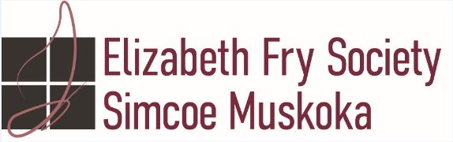

Restorative Justice Facilitator
Job Posting

This position is a part of the bargaining unit with OPSEU
Full Permanent Position
$20.91 per hour
Compensation according to the Collective Agreement, classification Restorative Justice Worker (.5) and Volunteer Coordinator (.5)
Submit resumes to: rhondal@elizabethfrysociety.com

The Restorative Justice Facilitator under the direction of the Director of Community Justice Programs is responsible for facilitating Restorative Justice Circles throughout Simcoe County and for management of volunteers for the Youth Justice Committee and students in Community Justice Programs.

Responsibilities
- Administer and facilitate Restorative Justice Circles.
- Comply with Restorative Justice Protocols.
- Maintain flexible hours that allow for meeting with clients, parents and community partners.
- Conduct evaluation of RJ circles.
- Be available during YJC meetings to oversee meetings.
- Attend YJC meeting if necessary.
- Maintain flexible hours that allow for meeting with clients, parents and community partners.
- Accept applications for and interview Youth Justice Committee volunteers.
- Train volunteers.
- Coordinate, organize and attend volunteer meetings and volunteer appreciation events.
- Conduct evaluation of meetings as needed.
- Ensure monthly statistical data collection is submitted to Director of CJP and Ministry.
- Coordinate student placement requests.
- Oversee and supervise students completing placement with Community Justice ProgramsTravel throughout Simcoe County using own vehicle.
- Represent Elizabeth Fry Society of Simcoe County in a professional manner at all times, maintaining a positive, cooperative, supportive attitude and appearance.
Qualifications:
- Degree or diploma in youth work, social work, social service work, sociology, criminology, psychology, or equivalent in training and experience.
- Complete Criminal Record Check including Vulnerable Sector Check.
- Must have experience in mediation and/or facilitation of restorative justice circles.
- Experience in Volunteer Management an asset
- Current certificate in First Aid and CPR.
- Valid driver license and reliable vehicle.
Knowledge/Skills/Abilities
- Strong knowledge of criminal justice system and Youth Criminal Justice Act
- Strong knowledge of restorative justice principles and practices.
- Strong knowledge of family dynamics.
- Strong knowledge of impact on victims of crime.
- Facilitation skills necessary.
- Proficiency in the use of computers for word processing, presentations, data collection and management, email and internet.
- Bi-lingual in French and English is an asset
Elizabeth Fry Society respects, values and celebrates the unique attributes, characteristics and perspectives that make each person who they are. We also believe that bringing diverse individuals together allows us to collectively and more effectively address the issues that face our communities. It is our aim, therefore, that our board, staff and volunteers reflect these core values.

