Item |  | Strategic Outcomes | Presented By | Purpose  (Approval, Action, FYI, Discussion, Decision) | Time
1. | Welcome/Introductions |  | Co-Chairs | FYI | 5 mins
2. | Consent Agenda:  2.1 Approval of IPT Minutes: Sept. 8/20  2.2 Approval of Agenda  2.3 Warm Transfer Guidelines |  | Co-Chairs | Approval | 2 mins
3. | Business Arising:  - Coalition Dashboard/Indicators | 1,2,3,4 | Coordinator | Update | 10 mins
4. | New Business:
5. | Integration/Partnership Priority Updates  - Council/Executive Committee Updates  - Partnership Updates | 4 | Co-Chairs | Updates | 15 mins
6. | IPT Workplan  - Review of Year 3 work  - Creation of Working Groups  - Success Indicators | 1,2,3 | Coordinator | Review | 25 mins
7. | 2:30pm Working Group Sub-Meetings:  Cultural Competency  Lived Experience  Early Childhood Mental Health | 1,2,3 | Working Group | Update | 20 mins
8. | Working Group Updates | 1,2,3 | Leads | Updates | 10 mins

Next Meeting: November 10, 2020, 1:30-4:00pm

Strategic Priorities:
- Foster representation and equity by understanding and supporting the communities we serve
- Advance collective action to improve experiences for children, youth and families
- Advocate for service system change by forming a powerful voice
- Build on the knowledge of individuals and organizations to strengthen community wisdom

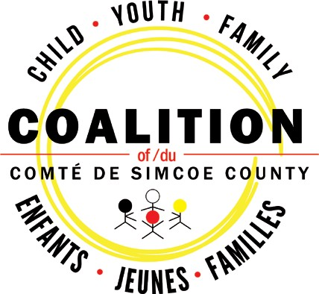

www.simcoecountycoalition.ca

