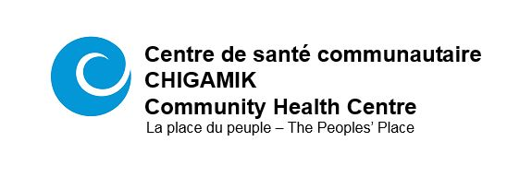
We are seeking a

FRANCOPHONE Mental health counsellor
As an FLS designated role; preference will be given
to a Francophone.

Terms: Part time, 0.5 FTE, temporary (May – September)
Salary: $62,000 - $70,000 annually (will be pro-rated to 0.5 FTE)

A shared sense of purpose. Chigamik Community Health Centre is committed to providing bilingual and culturally-sensitive primary health care, illness prevention and health promotion.

Job overview:
The Mental Health Counsellor works within a multi-disciplinary team to provide prevention, assessment, referral, clinical counselling, group programming and follow-up services to individuals and family members affected by mental health and substance use issues, specifically individuals who self-identify as Francophone.
Although evenings and occasional weekends will be required, we encourage our staff to maintain a healthy work/life balance.

Qualifications:
- Registered Social Worker or Psychotherapist in good standing with the appropriate Ontario College
- Comprehensive knowledge of client centered psycho-social treatment interventions, i.e. cognitive behavioural therapy, structured relapse prevention, solution focused modalities
- Practice from a harm reduction philosophy
- Knowledge of community resources, treatment centres, social service networks and organizations

Send your cover letter, resume and references by 12:00 noon Wednesday, April 15, 2020
CSC CHIGAMIK CHC, Unit 10 Midland ON L4R 0B7
Email: hr@chigamik.ca

a full job description can be viewed on the careers section of our website
www.chigamik.ca

CHIGAMIK Community Health Centre is an equal opportunity employer who seeks qualified candidates who share our commitment to equity, diversity and inclusion. While all qualified candidates are invited to apply, we particularly welcome applications from women, persons with disabilities, members of visible minorities, and LGBTQ+ persons. Job applicants requiring accommodation to participate in the hiring process should contact the Office Manager at 705-527-4154 ext. 200 to communicate accommodation needs. We thank all applicants, however, only those receiving an interview will be contacted.

CSC CHIGAMIK CHC encourages a scent-free environment. Please refrain from wearing fragrances and other scented personal care products while at the centre.

