Item |  | Strategic Outcomes | Presented By | Purpose  (Approval, Action, FYI, Discussion, Decision) | Time
1. | Welcome |  | Chairs | FYI | 5 mins
2. | Consent Agenda:  2.1 Approval of IPT Minutes: April 14/20  2.2 Approval of Agenda |  | Chairs | Approval | 2 mins
3. | Business Arising:  - Co-Chair for IPT |  | Chairs | Update | 5 mins
4. | New Business:
5. | Integration/Partnership Priority Updates | 4 | Chairs | Information | 15 mins
6. | 2018-2021 Strategic Workplan  Working Group Sub-meetings (2:00pm)  - Equity Diversity & Inclusion Group  - Transition Aged Youth  - Lived Experience Manual  - Warm Transfer Group | 1,2,3,4 | Working Groups | Discussion/Planning | 30 mins
7. | Lived Experience Guide | 1,2,3 | Working Group | Update/Review | 15 mins
8. | Cultural Competency Tool | 1,2,3 | Working Group | Update/Review | 15 mins

Next Meeting: June 9, 2020, 1:30-4:00pm

Strategic Priorities:
- Foster representation and equity by understanding and supporting the communities we serve
- Advance collective action to improve experiences for children, youth and families
- Advocate for service system change by forming a powerful voice
- Build on the knowledge of individuals and organizations to strengthen community wisdom

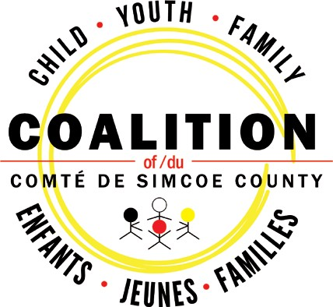

www.simcoecountycoalition.ca

