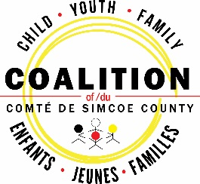
Vision: All children, youth and families thriving in a strong, nurturing community.

Mission: To maximize the capacity, effectiveness and cultural uniqueness of the child youth and family service system through collective efforts.

Executive Committee Meeting

Monday, December 16, 2019, 12:00 – 2:00p.m.
Town & Country Steak House, 76 Dunlop St. W., Barrie

AGENDA

Item | Presented By | Purpose  (Approval, Discussion, Decision, Action, FYI) | Time
- Welcome | Chair |  | 5 min
2. Consent Agenda:  2.1 Approval of Minutes: November 18, 2019  2.2 Approval of Agenda  2.3 Financial Report ending November 30, 2019 | Chair | Approval | 5 min
3. Business Arising:
- Coalition Living Wage Certification
4. New Business:  - NSM LHIN Membership Fees  - Morton Youth Services  - Windows 7 Update | EA  Chair  EA | Update  Discussion/Action  Decision | 5 mins  15 mins  10 mins
5. Coalition Claps  - E3/Community Connection – Out of the Cold Initiative | Chair | Approval | 5 mins
. Review of Council Agenda January 23, 2020  - Hot Topic: Cannabis and Mental Health  - Community Board/Telus Presentation  - Exit Tickets – November 28/19 | Chair | Approval | 10 mins

Next Meeting: January 20, 2020, 12:00pm-2:00p.m., Barrie Common Roof, 165 Ferris Lane, Barrie

